Electromagnetism

Iran university of science and technology

**Capstone: Electromagnetism - Project Report**

Parmida Haddadnejad

Fall 2022

The initial step in the simulation process involves defining the key parameters required for the model within the **Global Definitions** section of COMSOL. Specifically, three critical parameters are introduced: a, b and V0. The parameter a is used to represent the characteristic length of the rectangular region under consideration, while b is defined as the width of the copper cylinders that will be modeled. The parameter V0 denotes the potential applied to the system, which plays a pivotal role in the electrostatic calculations throughout the simulation.

Following the definition of these parameters, the next phase involves the construction of the physical geometry. Four copper cylinders with a very small depth are defined, as depicted in Figure 1. These cylinders are assigned dimensions of a for length and b for width, as outlined in the model specifications. The material properties of copper are applied to these cylinders, and they act as key components in simulating the electrostatic interactions within the system. These cylinders are critical to the modeling process, as they represent conducting boundaries, influencing the distribution of electric fields and potential within the defined domain.

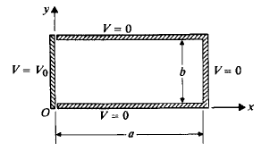

Figure 1

In addition to the copper cylinders, a large-radius sphere made of air is introduced to surround the rectangular region. This air sphere serves as the background or surrounding medium for the system. The air is assumed to be a non-conducting material with dielectric properties, and its purpose is to enclose the entire region where the electrostatic calculations are performed. By doing so, it ensures that the electric field behavior is appropriately constrained within the defined region of interest and provides a boundary for the model's calculations.

For the selection of physical phenomena, the **Electrostatics** module is chosen, as the simulation focuses on the behavior of electric fields and potentials in a steady-state (static) scenario. The **Stationary** study type is selected, as we are interested in obtaining a solution where the system has reached equilibrium, and no time-dependent variations are present. This selection ensures that the simulation solves for a steady electrostatic configuration rather than dynamic or transient behavior.

Once the geometry and physical properties are defined, we proceed to the Parametric **Sweep** functionality within COMSOL. This allows us to systematically assign a range of values to the previously defined parameters (a, b, and V0) and execute simulations across different parameter combinations. The **Parametric Sweep** feature enables the exploration of how variations in these parameters impact the resulting electric fields and potential distributions, providing a more comprehensive understanding of the system's behavior under different conditions.

Upon completion of the simulation runs, we proceed to analyze the results in the **Results** section. First, under the **Electric Potential** subsection, we generate a plot that shows the distribution of the electric potential throughout the domain. This visualization is crucial for understanding the spatial variation of the potential in response to the applied boundary conditions and the configuration of the conducting objects. By examining the potential distribution, we can gain insights into the electrostatic equilibrium state within the system.

Additionally, we utilize the **Norm Electric Field** plot to visualize the electric field strength at various points within the domain. This plot provides essential information about the magnitude and direction of the electric field vectors, offering a detailed view of how the electric field interacts with the conductors and the surrounding medium. The analysis of the electric field distribution is a critical step in understanding the forces at play within the system and how they relate to the applied potential.

In conclusion, by following this systematic approach, we are able to generate detailed and accurate simulations of the electrostatic behavior within the defined system. The combination of potential and electric field analyses provides a comprehensive understanding of the system's electrostatic properties, which serves as the foundation for further investigation and potential optimization.

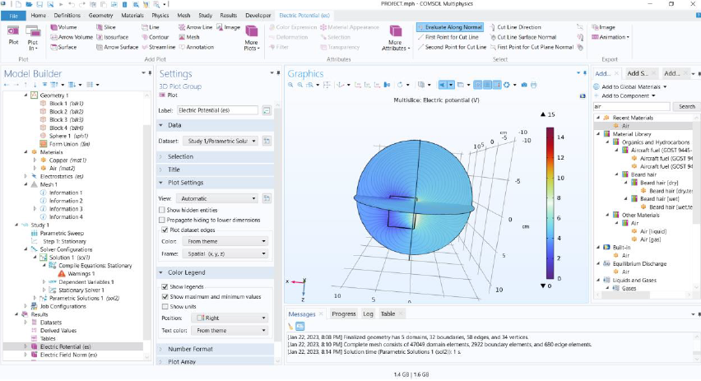

Figure 2

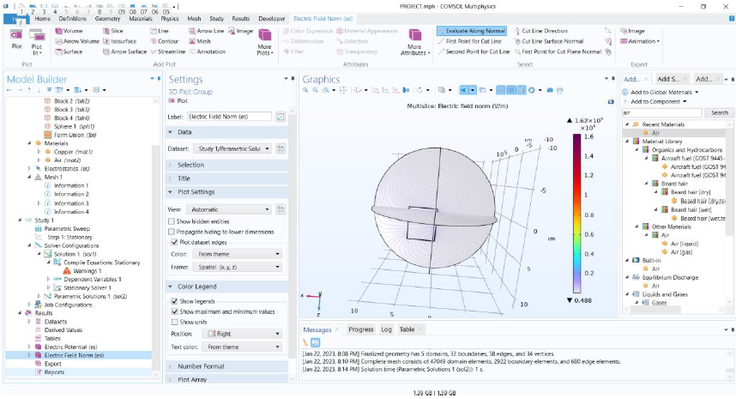

Figure 3